**Project Report**

**Title: Fake Reviews Detection System Using Python**

**Group Members:**

**Ibrar Ul Hassan Shami (UW-23-CY-BS-018)**

**Muhammad Azfar Waqas (UW-23-CY-BS-013)**

**Saad Ali (UW-23-CY-BS-050)**

Table of Contents

**1. Introduction 3**

1.1. Purpose: 3

1.2. Code Structure 4

1.3. Targeted Operating Systems 5

1.4. Compatibility with other Systems 6

1.5. Targeted Hardware Platforms 7

**2. Overall Description 8**

2.1. Manageability 8

2.2. User Classes and Characteristics 10

2.3. Design and Implementation Constraints 12

**3. Non-Functional Requirements 14**

3.1. Performance Element 14

3.2. Software Quality Attributes 16

**4. Other Requirements 18**

4.1. Hardware Interface 18

4.2. Software Interface 18

4.3. User Interface 19

**5. Execution: 20**

# **Introduction**

The Fake Review Detection System is a machine learning-based solution designed to identify and prevent the spread of deceptive reviews on online platforms. By analyzing textual content, sentiment, and metadata, the system distinguishes between genuine and fake reviews with high accuracy. Utilizing advanced techniques like TF-IDF vectorization and Support Vector Machine (SVM) classifiers, it provides reliable predictions. This system aims to enhance trust and transparency in e-commerce by minimizing the influence of misleading reviews on consumer decisions.

## Purpose:

The purpose of our Fake Review Detection System is to identify and classify online reviews as either fake or genuine. The system aims to:

* **Detect Deceptive Reviews**
* Identify fake reviews that could mislead potential customers.
* **Promote Trust in E-Commerce**
* Help users make informed decisions by ensuring the reliability of reviews.
* **Analyze Review Metadata**
* Leverage additional factors, such as verification status, to improve classification accuracy.
* **Enhance Consumer Protection**
* Reduce the influence of fake reviews on customer purchases.
* **Provide Accurate Predictions**
* Deliver high precision in distinguishing between genuine and fake reviews using machine learning
* **Support Businesses**
* Protect brands and sellers from the adverse effects of fraudulent reviews.
* **Automated and Scalable Detection**
* Ensure the system can process large volumes of reviews efficiently.
* **Encourage Transparency in Online Platforms**
* Contribute to creating a fair and credible digital marketplace

## **Code Structure**

The system’s code is designed as follows:

* **Libraries**:
* **Pandas**: For data manipulation and analysis.
* **Numpy**: For numerical computations and efficient array operations.
* **Scikit-learn**: For machine learning tasks, including TF-IDF vectorization, model training, and evaluation.
* **Scipy**: For handling sparse matrix operations.
* **NLTK/Spacy**: For natural language processing tasks like tokenization and stop word removal
* **Functions**:
* **preprocess_text**: Cleans and preprocesses review text.
* **remove_tags**: Removes HTML/XML tags from input text.
* **train_model**: Trains the machine learning model.
* **test_model**: Evaluates the model on test data and logs performance.
* **vectorize_data**: Converts text into numerical features using TF-IDF.
* **combine_features**: Merges TF-IDF features with metadata.
* **predict_review**: Classifies reviews as "Fake" or "True."
* **log_prediction**: Logs predictions for auditing.
* **load_model**: Loads a saved pre-trained model for predictions.

## Targeted Operating Systems

The targeted systems for the **Fake Review Detection System** include the following:

* **Operating Systems:**
  + The system is designed to run cross-platform, supporting **Windows**, **MacOS**, and **Linux**, given the platform-independent nature of Python and its libraries.
* **Python Dependencies:**
  + Utilizes Python libraries such as pandas, scikit-learn, and nltk, which are compatible with multiple operating systems.
  + The system employs scipy.sparse and TfidfVectorizer, which work seamlessly on supported Python distributions.
* **Resource Requirements:**
  + The program is optimized for systems with at least **8 GB of RAM** and a modern processor to efficiently handle the vectorized review data and large datasets.
* **Integration:**
  + The system is capable of being deployed in **local environments** or **server-based platforms** for scalability.
  + Can integrate with e-commerce platforms or data analysis tools via APIs for automated review processing.
* **Development Environment:**
  + Built and tested in **VS Code** with Python 3.x and compatible library versions, ensuring flexibility and accessibility for developers.

## **Compatibility with other Systems**

The **Fake Review Detection System** is designed to be highly adaptable and can potentially integrate with other platforms or systems with some modifications:

* **Operating System Adaptation:**
  + The system is **cross-platform compatible** and can run on **Windows**, **Linux**, and **MacOS**. However, adjustments may be required depending on the target system’s file paths, libraries, and configurations.
* **Library and Dependency Adjustments:**
  + Ensure that libraries like scikit-learn, pandas, nltk, and scipy are correctly installed and compatible with the Python version available on the target system.
  + Additional steps may be required to set up NLTK data or ensure proper functioning of sparse matrix operations on different platforms.
* **Cloud and API Integration:**
  + The system could be integrated with **e-commerce platforms** via **APIs** for direct review analysis.
  + Adapting the model for real-time analysis would involve linking it to cloud-based services or other enterprise platforms.
* **Server-Side Deployment:**
  + The system can be deployed on **Linux-based servers** (e.g., Ubuntu) or **cloud providers** (AWS, Azure, etc.) with slight changes to accommodate the specific hosting environment.
* **Resource-Specific Adaptation:**
  + For resource-constrained systems, optimizing the TfidfVectorizer and limiting the size of datasets might be necessary to ensure smooth operation.

## **Targeted Hardware Platforms**

The **Fake Review Detection System** is designed to run efficiently on a wide range of hardware platforms capable of supporting Python and its required libraries. Below are the key targeted platforms:

* **Personal Computers:**
* Standard desktops or laptops with at least **4-8 GB of RAM** and a modern **dual-core or quad-core processor** (e.g., Intel Core i3/i5/i7 or AMD Ryzen series).
* These systems can handle the model's processing requirements and text analysis effectively.
* **Servers:**
* Mid to high-tier servers with **16-32 GB of RAM or more** for large-scale analysis of multiple reviews simultaneously.
* Servers can be used for batch processing or integration into e-commerce platforms to analyze reviews in bulk.
* **Embedded Systems:**
* Lightweight deployments are possible on **Single Board Computers (SBCs)** like Raspberry Pi 4 with at least **4 GB of RAM**.
* These setups are suitable for smaller datasets or experimental purposes.
* **Virtual Machines (VMs):**
* The system can run in virtualized environments for testing or scalable deployments.
* Recommended configurations include **at least 2 CPU cores, 4 GB of RAM**, and proper storage allocation for datasets and libraries.
* **Cloud Platforms:**
* Deployment on **cloud-based hardware** (e.g., AWS EC2, Azure Virtual Machines, or Google Cloud instances) for scalable, distributed analysis.
* Provides the flexibility to handle varying loads with customizable hardware configurations.
* **Specialized Hardware:**
* High-performance systems like Dell PowerEdge servers or other specialized hardware optimized for large-scale computation can be employed for bulk review analysis with minimal latency.

# 2. Overall Description

## **2.1. Manageability**

The **Fake Review Detection System** has been designed with a strong emphasis on manageability to ensure it remains maintainable, readable, flexible, and robust. The following aspects contribute to the system's overall manageability:

* **Modular Design:**
* **Contribution:** The code is divided into distinct modules that handle tasks such as data preprocessing, vectorization, model training, and prediction. This modular structure allows developers to maintain, update, or replace individual components without impacting the entire system.
* **Descriptive Variable and Function Names:**
* **Contribution:** Variables and functions have been named to clearly reflect their purpose and functionality. For example, functions like testing and preprocess_text provide clear insight into their role, enhancing the code's overall clarity and reducing ambiguity.
* **Comments and Documentation:**
* **Contribution:** Inline comments and comprehensive documentation describe the purpose and logic of critical components. This makes the code easier to understand and extend, both for the current developers and future collaborators.
* **Consistent Coding Style:**
* **Contribution:** The system adheres to Python conventions (e.g., PEP 8), including proper indentation, meaningful spacing, and logical block separation. This consistency makes the codebase easier to navigate and review.
* **Code Reusability:**
* **Contribution:** Functions such as testing and preprocessing routines are designed for reusability. This minimizes code redundancy, enhances efficiency, and allows developers to repurpose components in similar projects or scenarios.
* **Scalability and Flexibility:**
* **Contribution:** The system's design ensures it can accommodate future changes, such as integrating new machine learning models or extending its capabilities to analyze additional datasets.
* **Unit Testing:**
* **Contribution:** The modular structure and well-documented functions facilitate the development of unit tests. Testing individual components, such as preprocessing logic or model predictions, ensures robustness and prevents potential issues during updates.

## **2.2. User Classes and Characteristics**

In the **Fake Review Detection System**, different user groups interact with the application based on their roles, responsibilities, and levels of technical expertise. This classification ensures that the system is designed to cater to the unique requirements of all stakeholders effectively, including user interfaces, reporting, and training needs.

* **Data Scientists/Developers:**
* **Technical Expertise:** High
* **Interaction with Code:** Extensive
* **Responsibilities:**
* Developing and maintaining the system, including training machine learning models.
* Optimizing algorithms for enhanced accuracy and efficiency.  
  Debugging and extending functionalities, such as incorporating additional datasets or features.
* Ensuring the system is compatible with new technological standards.
* **Business Analysts:**
* **Technical Expertise:** Moderate
* **Interaction with Code:** Limited
* **Responsibilities:**
* Using reports generated by the system to analyze review trends and patterns.
* Providing insights into fake review behaviors to improve business strategies.
* Recommending adjustments to the system parameters based on emerging trends.
* **IT Support Staff:**
* **Technical Expertise:** Moderate
* **Interaction with Code:** Limited
* **Responsibilities:**
* Monitoring the system's performance and ensuring it runs smoothly.
* Assisting with installation, deployment, and configuration.  
  Escalating technical issues to developers when necessary.
* **End-Users (Non-Technical Staff):**
* **Technical Expertise:** Low
* **Interaction with Code:** Minimal to None
* **Responsibilities:**
* Receiving outputs (e.g., labels indicating "Fake" or "True" reviews).
* Reporting inconsistencies or suspicious trends to administrators.
* Utilizing insights from the system to improve customer engagement and satisfaction strategies.
* **Management/Decision Makers:**
* **Technical Expertise:** Low to Moderate
* **Interaction with Code:** Limited
* **Responsibilities:**
* Reviewing high-level summaries or reports generated by the system.
* Making decisions about system deployment, infrastructure upgrades, or further investment in AI tools.
* Delegating tasks to technical teams for implementation or troubleshooting.

## **2.3. Design and Implementation Constraints**

The design and implementation of the **Fake Review Detection System** were influenced by several constraints to ensure its effectiveness, usability, and compliance with best practices in artificial intelligence and data handling. Below are the key constraints that shaped its development:

* **Data Availability and Quality:**
* **Requirement:** Access to a diverse and balanced dataset of verified and fake reviews for training and testing.
* **Impact:** The model's performance depends on the quality of data, requiring preprocessing steps to clean, balance, and prepare datasets for meaningful results.
* **Model Performance:**
* **Requirement:** Achieve high accuracy, precision, and recall to minimize false positives and negatives.
* **Impact:** Algorithms and parameters were fine-tuned to ensure reliability, but computational constraints might limit achieving ideal metrics.
* **Computational Resource Limitations:**
* **Requirement:** The system should operate on systems with standard hardware specifications, including desktops and laptops.
* **Impact:** Lightweight machine learning models and libraries (e.g., Scikit-learn, NLTK) were used to ensure efficient operation on commodity hardware.
* **Data Security and Privacy:**
* **Requirement:** Ensure that review data is processed securely and does not expose sensitive or private user information.
* **Impact:** Proper anonymization techniques and secure storage methods were implemented to handle review data responsibly.
* **Usability and Accessibility:**
* **Requirement:** Provide a simple and intuitive interface for users with varying technical expertise.
* **Impact:** The system was designed with straightforward input methods, like text-based review submission, ensuring accessibility for non-technical users.
* **Regulatory Compliance:**
* **Requirement:** Adherence to data protection regulations such as GDPR for handling user-generated content.
* **Impact:** The system ensures that only necessary data is stored temporarily, with safeguards to delete sensitive information after processing.
* **Algorithm Choice Constraints:**
* **Requirement:** The system must use interpretable machine learning algorithms for transparency in predictions.
* **Impact:** Algorithms like Support Vector Machines (SVM) was chosen for their balance of performance and interpretability.
* **Integration with Existing Systems:**
* **Requirement:** The system should integrate with existing platforms, such as e-commerce websites or review aggregators.
* **Impact:** Compatibility with APIs and data formats like JSON ensures smooth integration into larger systems.
* **Scalability and Adaptability:**
* **Requirement:** The system should scale to analyze large volumes of reviews and adapt to evolving fake review patterns.
* **Impact:** Modular design and support for retraining the model allow scaling and updates as needed.

# 3. Non-Functional Requirements

## **3.1.** Performance Element

The performance elements for the **Fake Review Detection System** are designed to ensure that the system operates efficiently and effectively across various scenarios. The following benchmarks and targets outline the system’s performance objectives:

* **Text Processing Speed:**
* **Benchmark:** The time taken to process a review and classify it as fake or genuine.
* **Target:** The system should classify reviews within **milliseconds to a few seconds**, depending on text length and system resources.
* **Classification Accuracy:**
* **Benchmark:** The system's ability to correctly identify fake and genuine reviews.
* **Target:** Accuracy should exceed **85%** in practical scenarios, with precision and recall maintained above **80%** for balanced performance.
* **Scalability:**
* **Benchmark:** The ability to handle a large volume of reviews simultaneously without performance degradation.
* **Target:** The system should process **at least 1,000 reviews per minute** under normal load and scale to higher volumes with distributed computing or optimization.
* **Memory Usage:**
* **Benchmark:** The amount of memory consumed during text vectorization, training, and prediction.
* **Target:** Memory usage should not exceed **70%** of available system memory during normal operation.
* **CPU Utilization:**
* **Benchmark:** The percentage of CPU resources utilized during the review classification process.
* **Target:** CPU usage should remain below **75%** during normal loads and not exceed **90%** during peak workloads.
* **Model Inference Time:**
* **Benchmark:** The time taken by the machine learning model to generate predictions once input is provided.
* **Target:** The inference time should remain under **500 milliseconds** for single reviews and under **2 seconds** for batch processing.
* **Batch Processing Capability:**
* **Benchmark:** The system's ability to handle and classify multiple reviews simultaneously.
* **Target:** The system should efficiently handle **batch sizes of up to 1,000 reviews** in less than **5 seconds**, depending on hardware capacity.
* **Robustness to Long Texts:**
* **Benchmark:** The system's performance in processing unusually long or complex reviews.
* **Target:** The system should maintain consistent processing time and accuracy even for reviews exceeding **1,000 characters**.

## 3.2. Software Quality Attributes

The **Fake Review Detection System** upholds several software quality attributes to ensure its effectiveness, usability, and maintainability. These attributes contribute to its reliability and overall performance:

* **Reliability:**
* The system must consistently classify reviews as genuine or fake with high accuracy.
* Mechanisms are in place to handle unexpected errors or invalid inputs, ensuring continuous operation.
* **Maintainability:**
* Modular design allows for individual components, such as preprocessing, model loading, and result evaluation, to be updated or replaced without impacting the entire system.
* Well-documented code with detailed comments and consistent naming conventions ensures ease of understanding for developers.
* **Performance:**
* The system is optimized to process large datasets efficiently, ensuring quick review classification.
* Resource utilization (CPU, memory) is balanced to maintain smooth operations even under heavy workloads.
* **Scalability:**
* The architecture supports scaling to process higher volumes of reviews, such as those from large e-commerce platforms.
* Capable of integrating additional models or features without compromising performance.
* **Portability:**
* Designed to operate across multiple platforms, including Windows, Linux, and macOS, with minimal adjustments to dependencies or configurations.
* All core functionalities rely on widely supported Python libraries for seamless cross-platform execution.
* **User-Friendly Interface:**
* Clear and structured command-line interface allows easy use by technical and non-technical users.
* Visualizations of results and summaries enhance user understanding of detected patterns.
* **Error Handling:**
* Comprehensive error-handling mechanisms prevent crashes during invalid data inputs or unexpected system issues.
* Meaningful error messages guide users and developers to take corrective actions effectively.
* **Extensibility:**
* The system design allows easy integration of additional models, datasets, or functionalities, such as multilingual support or real-time review processing.
* Modular components are adaptable to future advancements in natural language processing (NLP) and machine learning.
* **Security:**
* Ensures user data is processed securely, protecting against unauthorized access and manipulation.
* Logging mechanisms provide a secure trail for auditing and debugging.

# 4. Other Requirements

## 4.1. Hardware Interface

* **Direct Hardware Interaction:**

The **Fake Review Detection System** does not directly interact with hardware devices like printers or specialized display screens. However, it can be extended to support external devices if needed by integrating appropriate libraries or drivers.

* **Network Interface:**

The system relies on a network connection for several operations, including:

* **Dataset Retrieval:** Downloading or uploading datasets for training and testing via secure protocols like HTTPS.
* **Cloud Integration:** Communicating with cloud-based platforms (e.g., AWS, Google Cloud) for model training, storage, or deployment.
* **API Interaction:** Accessing external APIs for real-time review validation or sentiment analysis.  
  This interaction follows standard network protocols like TCP/IP to ensure seamless data transmission.

## 4.2. Software Interface

The system relies on several software components and libraries to execute its functionalities effectively:

* **Operating System:**
* Compatible with Windows, Linux, and macOS platforms.
* Requires Python 3.x environment to run the scripts and modules.
* **Dependencies:**
* **Natural Language Toolkit (NLTK):** Used for text preprocessing and feature extraction.
* **Scikit-learn:** Provides tools for machine learning model training and evaluation (e.g., SVM, logistic regression).
* **NumPy & Pandas:** For efficient numerical operations and dataset manipulation.
* **Matplotlib & Seaborn:** For data visualization and performance metrics plotting.
* **SQLite or File-based Storage:** For saving and retrieving datasets or logs.
* **Interoperability:**
* The system can be integrated with external systems or databases through APIs or data export in common formats (e.g., CSV, JSON).
* Modular design ensures compatibility with new machine learning libraries or frameworks.

## 4.3. User Interface

The system offers a user-friendly interface designed to accommodate both technical and non-technical users:

* **Command-Line Interface (CLI):**
* Allows users to execute the system through commands and arguments.
* Users can specify datasets, adjust preprocessing settings, or select machine learning models via command-line options.
* Clear instructions and error messages guide users during operations.
* **Visual Output:**
* Graphical summaries of results, such as confusion matrices, accuracy charts, and data distribution plots, are generated for user insight.
* Logs and classification outputs are saved in easily accessible formats.
* **Potential GUI Extension:**
* A graphical user interface (GUI) can be added using libraries like Tkinter or PyQt for users who prefer interactive point-and-click operations.
* The GUI can include file upload options, preprocessing configuration sliders, and real-time classification outputs.
* **User Experience Enhancements:**
* Descriptive prompts and detailed documentation help users understand how to operate the system.
* Logs and reports are presented in an organized format for better analysis.

# 5. Execution:

* **Dataset:**

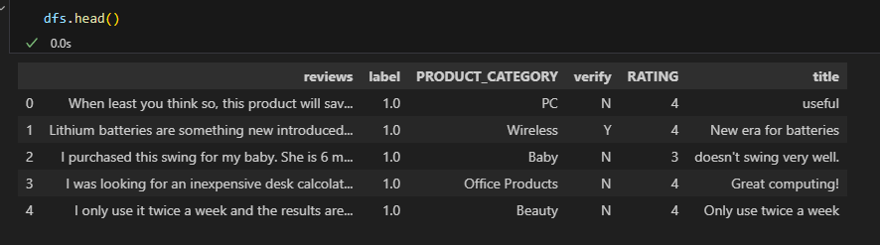

* **Preprocess Text:**

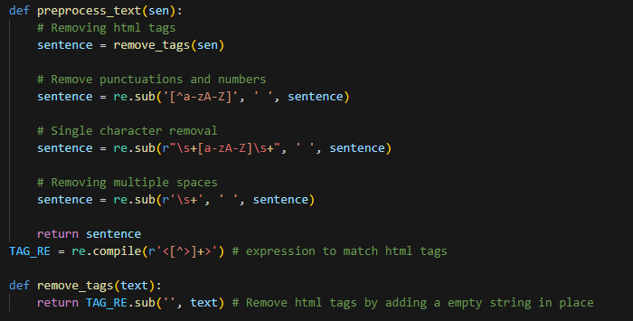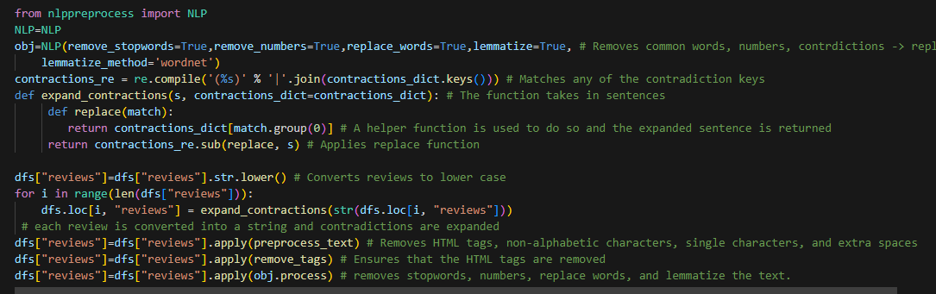

* **Model Accuracy and Saving:**

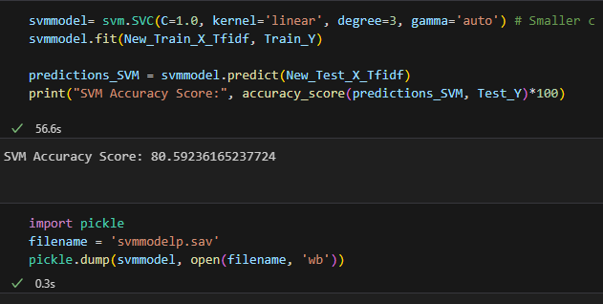

* **Review Detection:**

